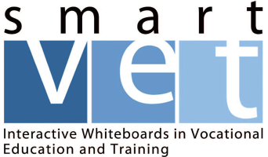

1 Day Workshop (Bootcamp)
on
Using Interactive Whiteboards (IWBs)
Limited Places Available
Thursday, 24 October - 10.00am to 4.00pm
Portlaoise Further Education Centre - Former CBS Secondary school
This workshop (bootcamp) is aimed at providing beginners or those with a limited capacity to use Interactive technologies with the practical skills to begin using the Interactive Whiteboard (IWBs) to enhance teaching and learning.
Participants will need basic ICT skills and should bring a laptop to the session.
Tea/coffee will be available on arrival and sandwiches, tea and coffee will be available at lunchtime.
There is no charge for this workshop.
This workshop is part of the SmartVET EU funded project to transfer good practice in using IWBs from the project’s European Partners to Irish education and training through Kildare and Wicklow ETB. ETBI is responsible for dissemination.
Full details of project available from: http://www.smartvetproject.eu/ 087 2304539
To register for workshop, please email the following details to ero@etbi.ie
Full Name:
Current post:
Mobile:
Email:
We will email you further details on Friday (18 October) – so it is important that you provide email address.

